OIPOA Meeting January 21, 2020

Attendees: Mark Robertson, Peggy Hughes, Wendy Hughes, Jean Cruz, Mary Stuart Alfano, Glenn Withers, Debbie Eckert, Mark Crissey, Leigh Simmons, Ida Moon, Com. Dean Walter and Com. David Green

Meeting Called to order @ 3:08pm
1st Jean 2nd Ida
Jean read the last meeting minutes, Minutes accepted 1st Wendy 2nd Glenn
Financial Report given by Mary Stuart Alfano
very detail report with very detail handout (see Attachment)
Insurance over budget (see attachment)
Postage, print and supplies actual lower than November (see attachment)
Super Saturday- actual lower than November (see attachment)
Keystone Cops no show for 3rd year
Bank Fee -7 still attempting to resolve with CAM (see attachment)
Fireworks Cam P&L YTD since May has reflected $8400 was expensed for fireworks, nothing reflected in any other CAM documents; town had not received payment and no cancelled checl; check never issued. Why error not noticed by CAM or anyone else? Check has been written and delivered to town. Asked Daisy Ivy to notify us when payment is due so this won’t happen again
Postage, Print & Supplies- CAM changed budget to $45,000 should be $5,000
Prepared application $6500 Concert and $1500 Trash Bash from Town ready for submission once CAM provides corrected Financials
Wayne Rowell will prepare taxes no cost but will need corrected 2019 Financials
CAM will be paid quarterly and Awesome Website Paid Annually more efficient
Reimbursement forms and code at CAM in Blue folder
Amend budget to have a line for Paypal Expenses accepted 1st Wendy 2nd Mark Crissey
Suggested Shopping for Insurance requested from CAM updated COD page
Resignation of Mary Stuart Alfano (see Attachment)
2 issues of too much accessibility of accounts and signatures regarding checks will help with transition to a new treasurer (see attachment)
Financial Report accepted 1st Glenn 2nd Mark C
Communication Committee - Mark spoke for Deb Foster (see attachment and email printed copy on file)
Deb Foster sent email to all board members due to Surgery could not attend Meeting, great job.
One change to Facebook - Membership Cards to be picked up at Heathers Office 7161 Beach Dr, Beside Island Hoppers Bicycle shop. No one was aware of this
Concert Committee - Wendy Hughes
1 contract still outstanding, waiting on Steve Owens. Wendy Hughes asking ROTC for color guard for 3 Dates
Memorial Day, Labor Day and September 11 Halloween Concert still under consideration
Once everything is finalized Deb Foster will put concert schedule on Webpage and Facebook. Park will meet deadline of May22 according to General Contractor but Dean Walters expressed his concerns on the park deadline being meet.

Concert Sponsorship Committee - Leigh Simmons
Forms are being sent out with map, band schedule and self-addressed envelope to be sent back to CAM. Car Dealers suggested as new sponsors. Leigh stated she has plans to approach some new sponsors, right now they are in track with the same number of sponsors as last year.
Membership Committee Jean Cruz
Letters finally went out last week, Glitch and miss communication reason for delay
Heather owns whole process Should be a better year. Checks this year should be processed in more timely manner. Hope to get new home owners. Question raised why not just a membership card and no discount cards printed would save money. Leigh Simmon stated business more likely to be in program if name is in print. For next year work on Business members and a welcome package to new home owners
Kite Day Committee- Debbie Eckert
All sellable kites have been ordered and is in. Waiting on final commitment for our free give away kites from Steven Kligman co-owner of Klig’s Kites of NMB and MB. He talking to his distributors for either low cost or free kites for the POA. Will know by the 3rd week of February will get sign to acknowledge his contribution to our cause. Deb will work with Mark Crissey to get credit card square for Kite Day. There will be a processing fee of 2.6%. Contact at 1st Bank to set up a separate account – Vicki Williamson. Only one person @ Kite Day will be handling Square.
New Business
Credit Cards to be taken at Kite Day (see above)
Storage Unit Trailer
Mark R - can be fixed with Calk and Patched leak
Debbie E - also Bugs and Bees also was told by Daisy Ivy wants trailers gone for employee parking and easier turn around for trucks Might be able to find storage space at maintenance building.
Mark R will talk to town before fixing trailer
Exercise Stations- Mark Crissey HB has them and would be good for OIB. Everyone agreed and needs to be address to Town for consideration Mark Crissey will move forward on this concept
Paws-Ability ask for sponsorship for Mardi Gras party cost $200.00. Donated monies condition needs to be used for Island use only. Majority voted yes 1st Leigh 2nd Jean
Adjourned 1st Jean 2nd Leigh

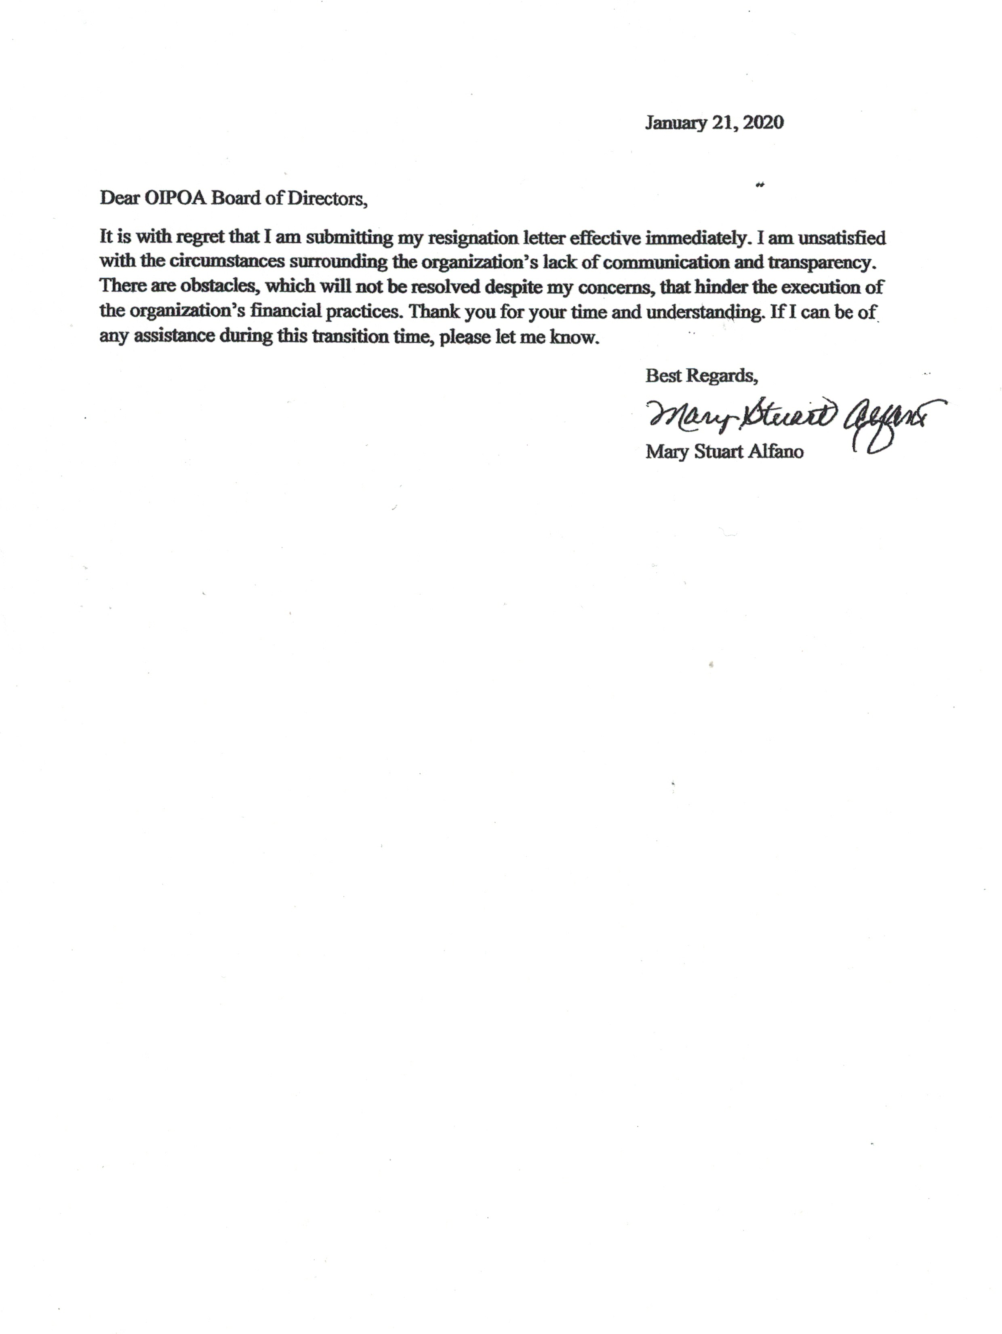

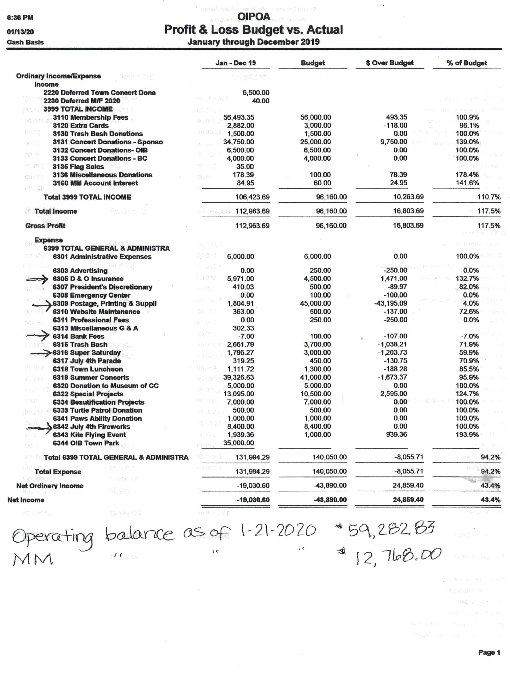Communications Committee Report Board Meeting: 1/21/20
1. OIPOA FaceBook Page
We have renamed the page to Ocean Isle Property Owners Association & Summer Concert Series (rather than Schedule), and if you do not follow that page, please do so. It is where we will regularly post real-time updated information on events, concerts, activities, and community news. We have updated the logo, the landing page photo, and the page description. We have been posting pertinent information on a regular basis, and the recent posts have been performing very well. The following metrics data was downloaded from Facebook for the last couple of weeks:
 13%
We have responded to many requests sent through Facebook Messenger; the majority of which were pertaining to the non-receipt of the annual renewal form. We also filed all of the completed responses under the Done folder in Messenger, in case anyone needs them.
Total Page Views
 178%
Page Previews
 50%
Page Likes
 660%
People Reached
 93%
Post Engagement
 131%
Post Engagement
 131%
Response Rate
 13%
Response Rate
 13%
Response Rate
Number of Page Followers:  925%
2. Website – OIPOA.COM
We obtained the Website login information from Allison, who was extremely helpful providing assistance by turning over all of her archived electronic files. We discovered that there was a problem gaining access to our account, and after contacting the Awesome Website Guys (Dave), they, too had the same problem and could not access our account. They created a support ticket that went to the
programmers who were finally able to resolve the problem.
After accessing the account, we found that much of the overall content had not been updated in a very long time. The website needs a lot of re-design and content work, but we were able to remove the old information and replace it with current information. As most of the inquiries we’ve received have been regarding Memberships, we have relocated the Membership Form link onto the home page. We are in the process of creating events for all of the upcoming activities, concerts, etc. and plan to display the “next event” on the home page.
It is a work in progress. We can certainly use a lot of photos and graphics, so please feel free to send them to oceanislepoa@gmail.com.
3. Email – OCEANISLEPOA@GMAIL.COM
We created a new email address, oceanislepoa@gmail.com (please make sure add this to your address book) and have re-directed all website inquiries to it. From 1-1 to 1-15-20, we have received (and responded to) the following inquiries:
Admin 1 Concert Sponsorship 1 Events 1 General Inquiry 1 Membership 13 Volunteers 1 Website 5
It is monitored on a daily basis. All inquiries and responses have been files in the corresponding folders. I am happy to provide the password to anyone who would like to review the emails. We would like this to be the central communications address for the entire community going forward, so we have listed/referred to it in all Email, Website, Facebook, and Messenger communications.
4. MailChimp Account – Email Marketing
I recently received the MailChimp account login details from Lisa Crissey, but I have not done much work with it yet. I intend to collect the 2020 Membership forms from CAM and validate all of the email addresses contained them. Hopefully at the end of this year, we can provide the renewal letters and forms electronically in a group email blast early (in December), and then mail copies to only those whom we have not received back, thereby reducing the work efforts and costs associated with the overall membership process.
